2018-2019 A YEAR IN RETROSPECT

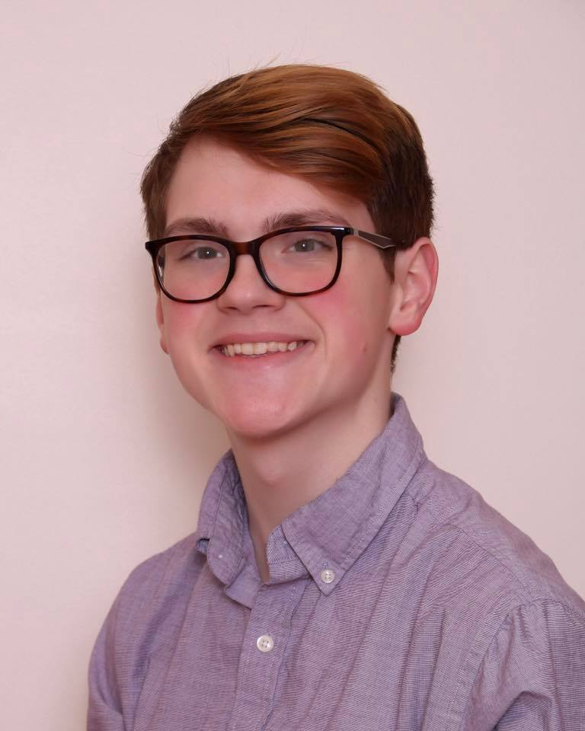
MUSICAL THEATRE SCHOLARSHIP
ACCEPTED INTO MUSICAL THEATRE PROGRAM
Daniel Blankenship, son of Larry and Anne Blankenship auditioned and has been accepted into the B.F.A. in Musical Theatre program at the University of South Dakota. Daniel also received a Musical Theatre Scholarship from the University of South Dakota. He is a senior at Webster City High School. Daniel is a voice student of MaryAnn McSweeny-Buhr. Congratulations!

PRE-CONCERT RECITAL
A Pre-Concert Recital was held on Sunday, April 14 at the Fort Dodge Middle School. This partnership between the Fort Dodge Area Symphony and the Youth Honors Recital program allows students selected from the Youth Honors Recital by a panel of three judges to perform in the Pre-Concert Recital preceding the Fort Dodge Area Symphony’s Young Artists Concert. McSweeny’s School of the Performing Arts was represented by the following vocalists: Hannah Lukehart performing “Over the Rainbow” and a vocal ensemble representing the Fort Dodge Area Children’s Chorus comprised of Brylee McClintock, Grace Nichols and Zuri Roe performing “Shining Moon”. Area pianist, Michelle Havlik-Jergens, Webster City provided piano accompaniments for this event. Congratulations!

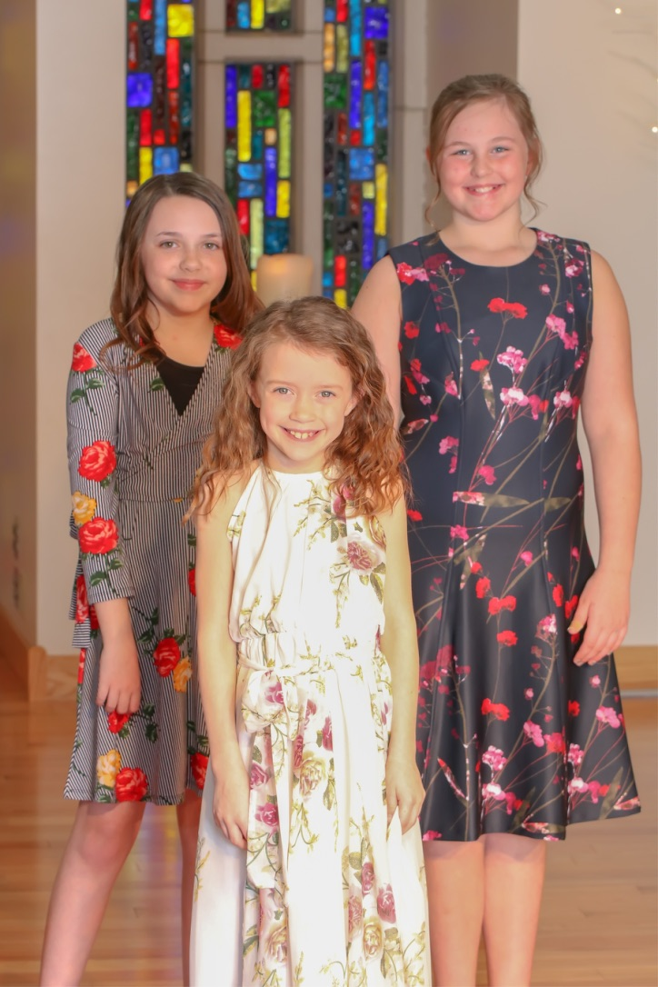
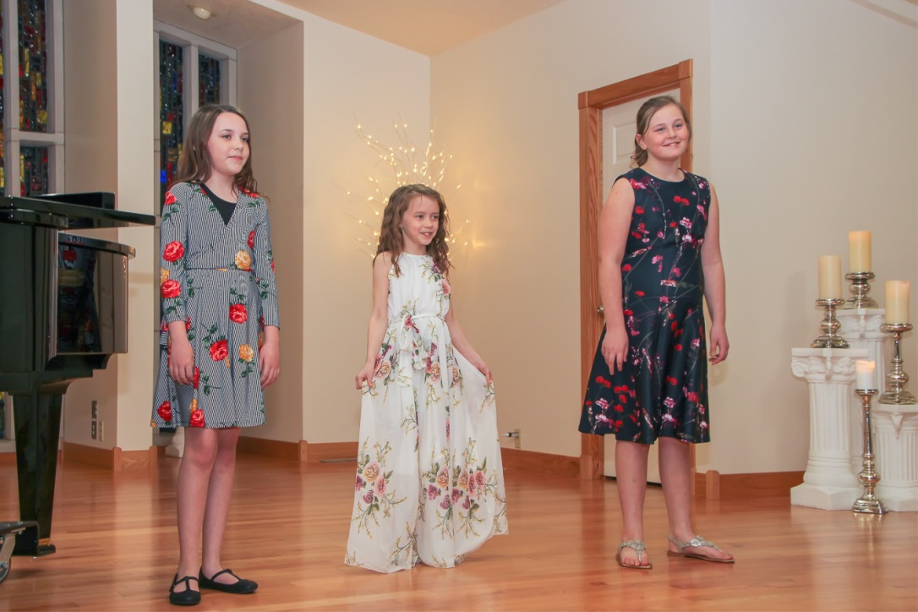

33rd ANNUAL YOUTH HONORS RECITAL
The 33rd Annual Youth Honors Recital was held on Friday, March 29 at McSweeny’s School of the Performing Arts. The recital co-sponsored by the Fort Dodge Area Symphony and McSweeny’s School of the Performing Arts for outstanding young soloists featured musicians in grades 2nd – 8th grades representing seven communities including Burnside, Fort Dodge, Gowrie, Humboldt, Jefferson, Pomeroy and Webster City. The students performing were recommended by ten area music teachers to best represent their studios and schools. The Youth Honors Recital featured voice, piano, and instrumental soloists as well as a vocal ensemble and piano trio. Vocalists selected to participate in the Youth Honors Recital were soloists Dari Cook, Jordan Kahl, Hannah Lukehart, and Alyssa Speck and a vocal ensemble representing the Fort Dodge Area Children’s Chorus comprised of Brylee McClintock, Grace Nichols and Zuri Roe. Area pianist, Michelle Havlik-Jergens, Webster City provided piano accompaniments for this event.

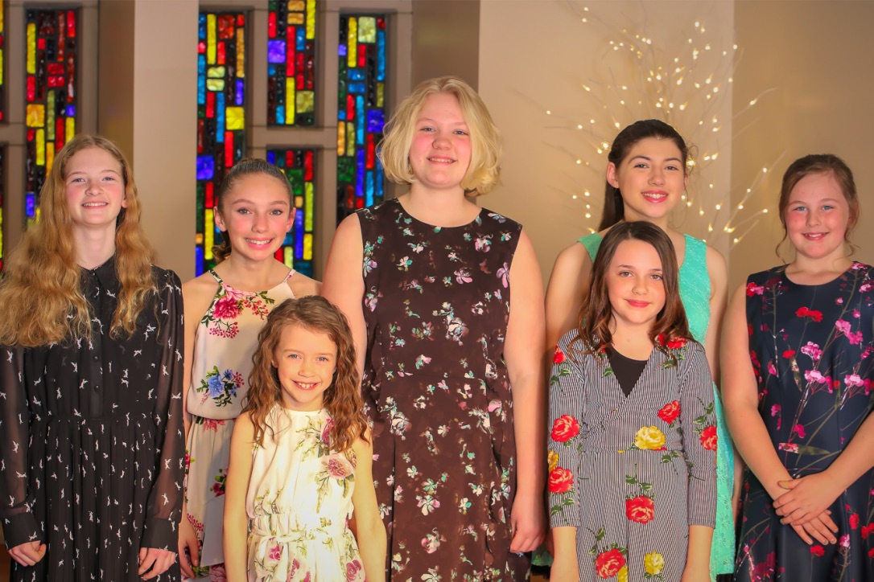

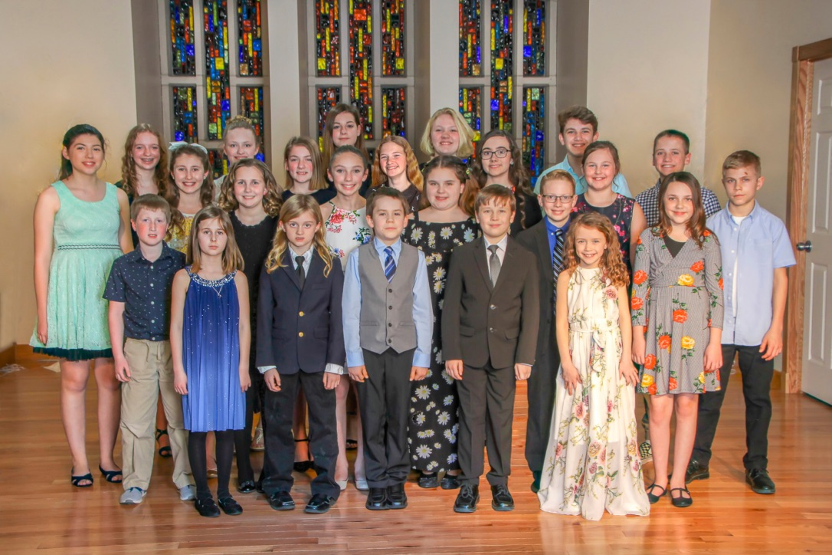

IOWA HIGH SCHOOL SPEECH ASSOCIATION’S STATE CONTEST
Daniel Blankenship participated in the Iowa High School Speech Association’s State Individual Contest on Saturday, March 9. He performed “Grow for Me” from “Little Shop of Horrors” and received a Division 1 rating in the Solo Musical Theatre Category. Daniel is the son of Larry and Anne Blankenship and a senior at Webster City High School. He is a voice student of MaryAnn McSweeny-Buhr. His high school speech coaches are Heather Noethe, Sofia Seliger and Zac Sjoberg. Congratulations!

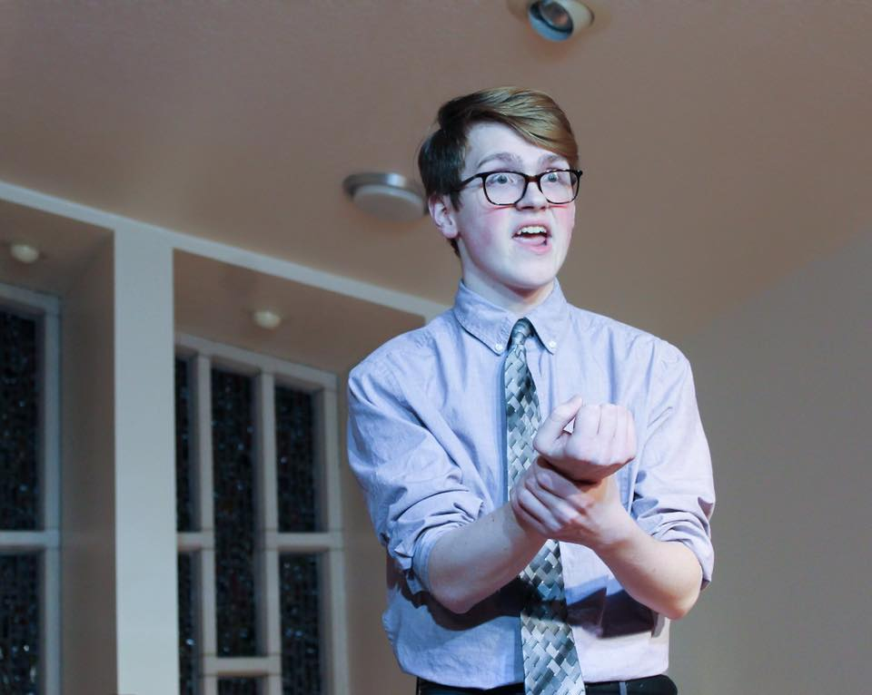
IOWA HIGH SCHOOL SPEECH ASSOCIATION’S DISTRICT CONTEST
Daniel Blankenship participated in the Iowa High School Speech Association’s District Individual Contest on February 27. He performed “Grow for Me” from “Little Shop of Horrors” and received a Division 1 rating in the Solo Musical Theatre Category. Daniel is a senior at Webster City High School and the son of Larry and Anne Blankenship. Daniel is a voice student of MaryAnn McSweeny-Buhr. His high school speech coaches are Heather Noethe, Sofia Seliger and Zac Sjoberg. Congratulations!

VOICE RECITAL
Voice students of MaryAnn McSweeny-Buhr presented a voice recital, “I’ll Be Home for Christmas” on December 15. The recital included vocal soloists, a vocal ensemble and the Fort Dodge Area Children’s Chorus.

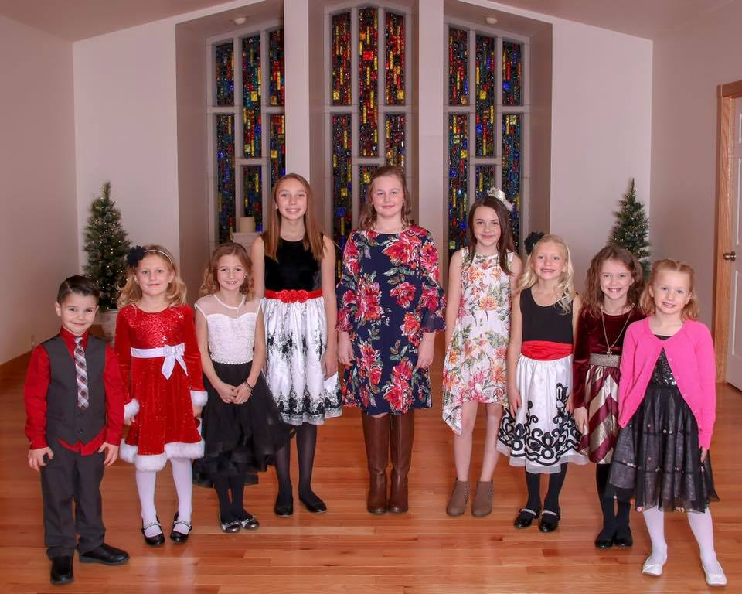

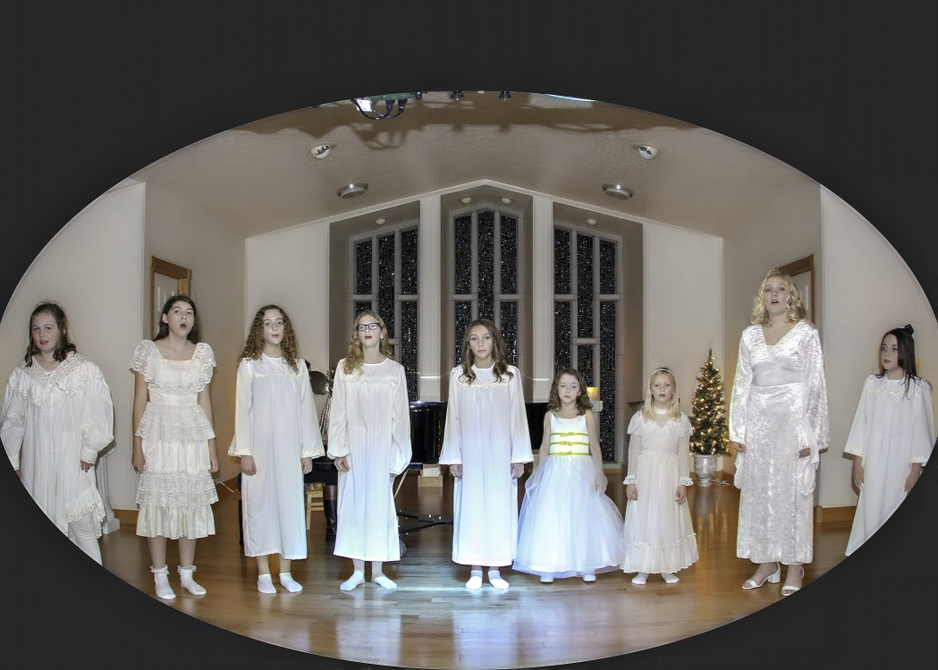

2018 IOWA CHAPTER NATS AUDITIONS
Participating in the 2018 Iowa Chapter NATS Auditions was Daniel Blankenship, son of Larry and Anne Blankenship, Webster City. Daniel sang in both the classical singing and musical theatre categories. The auditions were held on November 2-3 at Simpson College in Indianola, Iowa. He was accompanied by area pianist, Michelle Havlik-Jergens. Daniel is a voice student of MaryAnn McSweeny-Buhr.

2018 MESSENGER READERS’ CHOICE AWARD
Thank you to our professional instructors, enthusiastic students, supportive parents and a community and area that supports the Arts. Because of you, McSweeny’s School of the Performing Arts was chosen “Best Music School” in the 2018 Messenger Readers’ Choice Awards.
(Possibly Add: Readers’ Choice Logo)

MARY POPPINS JR.
Performing the leading role of Bert in the Webster City Community Theatre’s production of “Mary Poppins Jr.” was Daniel Blankenship, son of Larry and Anne Blankenship and a senior at Webster City High School. Performances were held on October 12-14 and October 19-21. Daniel is a voice student of MaryAnn McSweeny-Buhr. Congratulations!

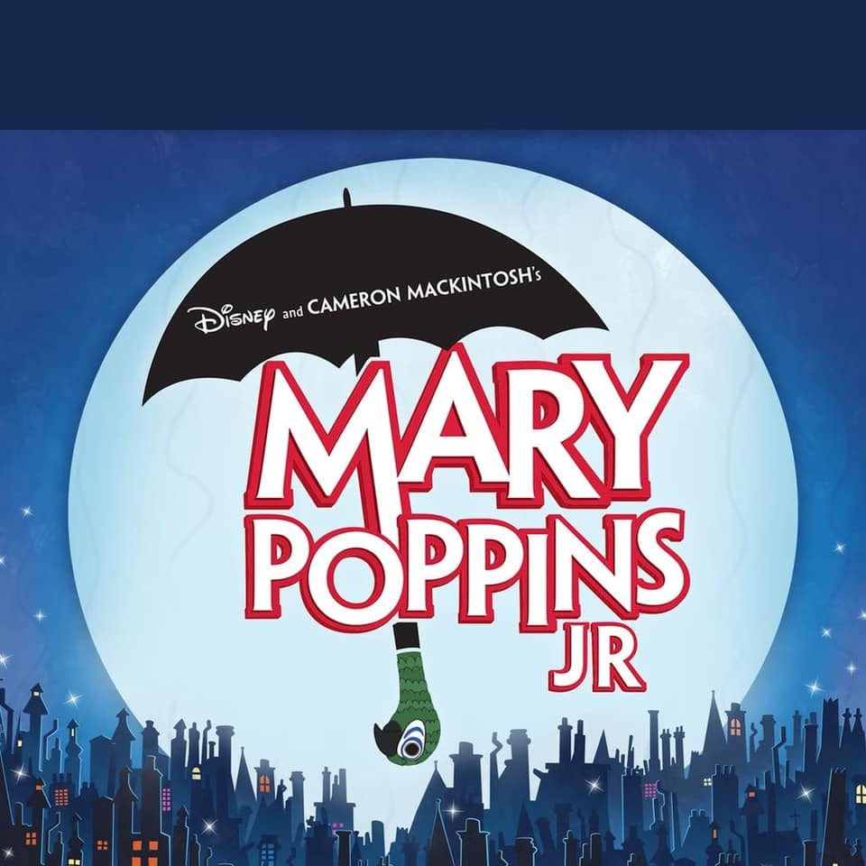

COLLEGE VISITS
Daniel Blankenship and Tristan Isaacson visited several colleges and universities this fall. On October 11, they visited Buena Vista University in Storm Lake, Iowa. On November 15, Daniel visited the University of South Dakota in Vermilliion, South Dakota.

During these visits, they met with Admissions, had a campus tour, met with music and theatre department faculty, had sample voice lessons, attended a choir rehearsal and attended a recording technology class.

They were accompanied on these college visits by their voice instructor, MaryAnn McSweeny-Buhr.
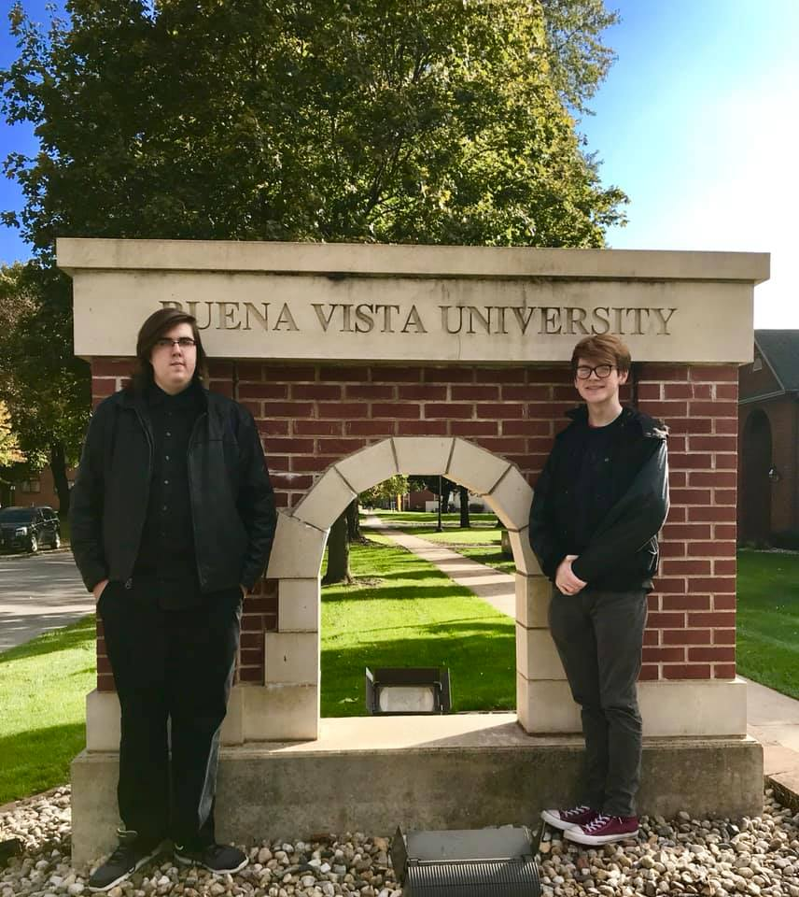

BILL RILEY STATE FAIR TALENT SEARCH SPROUT CHAMPION
BILL RILEY STATE FAIR TALENT SEARCH SPROUT SEMIFINALIST
Performing in the Semifinal Round of the Bill Riley State Fair Talent Search on August 18 at the 2018 Iowa State Fair on the Anne and Bill Riley Stage was Hannah Lukehart. Hannah performed “How Far I’ll Go” in the Sprout Division. She is 11 years old and the daughter of Christina Sells and Johnny Lukehart.

Hannah Lukehart was selected a Bill Riley State Fair Talent Search Sprout Champion on August 18 at the 2018 Iowa State Fair. Hannah performed "How Far I'll Go" on August 19 and her performance was broadcast on TV IPBS channel 11. Hannah was accompanied by area pianist, Michelle Havlik-Jergens. She is a voice student of MaryAnn McSweeny-Buhr. Congratulations!

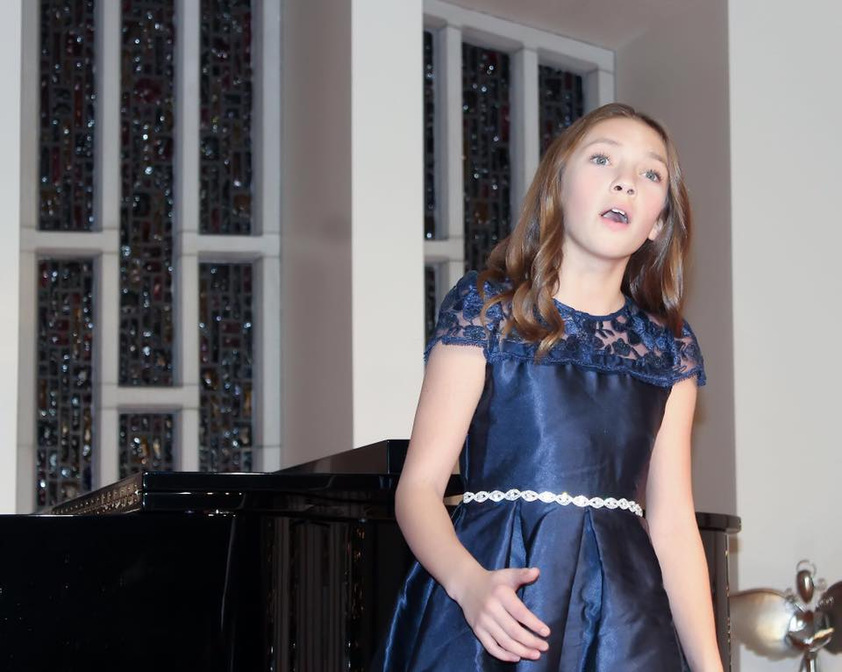
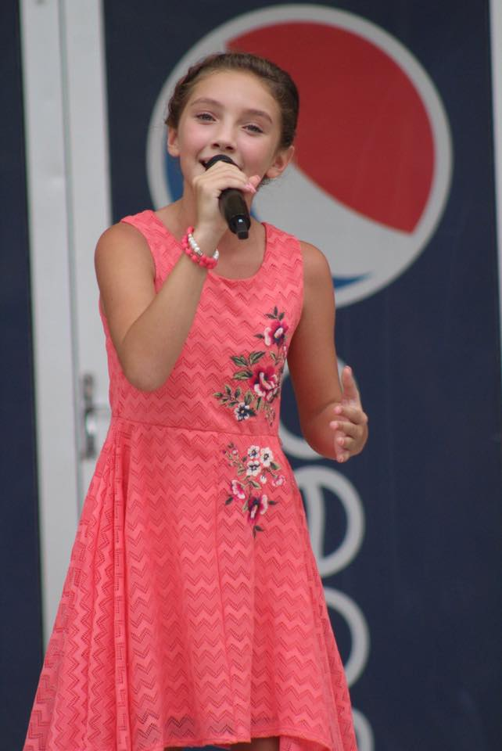
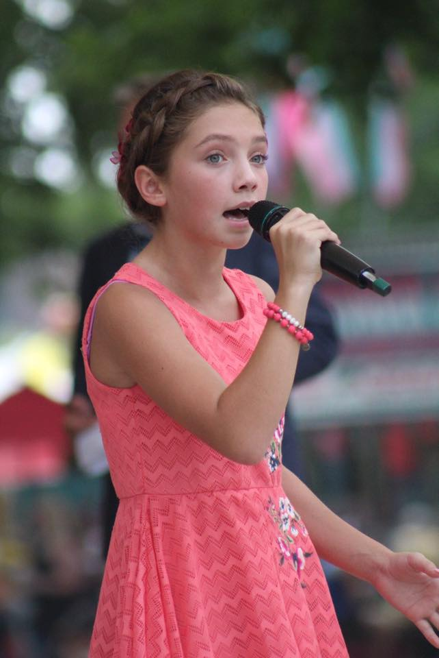
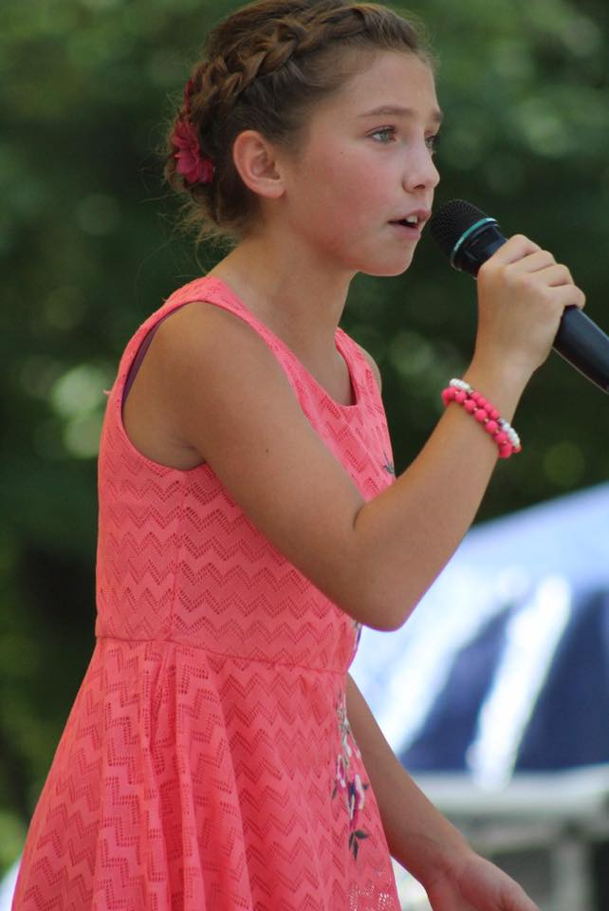
BILL RILEY STATE FAIR TALENT SEARCH PRELIMINARY ROUND – IOWA STATE FAIR
Performing in the Preliminary Round of the Bill Riley State Fair Talent Search on August 10 at the 2018 Iowa State Fair on the Anne and Bill Riley Stage were Hannah Lukehart and Daniel Blankenship. Hannah performed “How Far I’ll Go” in the Sprout Division. She is 11 years old and the daughter of Christina Sells and Johnny Lukehart. Daniel is 17 years old and the son of Larry and Anne Blankenship. He sang “The Things I Learned in High School” in the Senior Division.

Hannah Lukehart was selected a Bill Riley State Fair Talent Search Sprout Semifinalist on August 10 at the 2018 Iowa State Fair. Congratulations!

"I was thrilled to be able to support Hannah and Daniel in their Bill Riley State Fair Talent Search journey. They are both hard working and talented performers who exhibit kindness, humility and are wonderful role models for younger singers. I am also thankful for all the life lessons singers learn through their participation in the Bill Riley Talent Shows at both the local and state level. Singers learn to persevere and ‘never give up’, are provided with many opportunities to develop their stage presence, self-confidence, work ethic and ultimately the push to excel. The Bill Riley Talent Search is truly a wonderful program to nurture young singers and musicians.” (MaryAnn McSweeny-Buhr – August, 2018)

They were accompanied by area pianist, Michelle Havlik-Jergens. Both are voice students of MaryAnn McSweeny-Buhr.
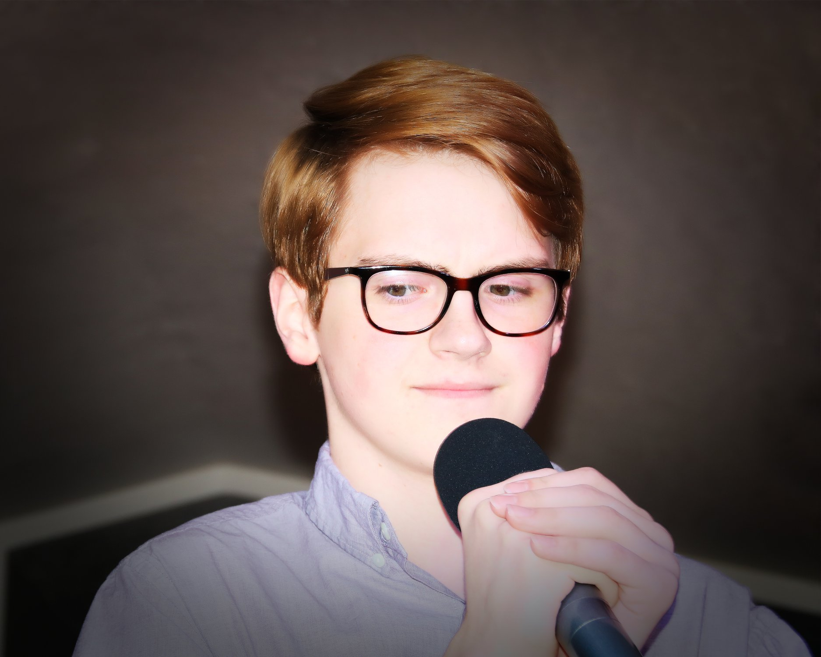

DESIRING THE ARTS FESTIVAL 2018
A special thank you to Hannah Lukehart and Daniel Blankenship for their commitment and musical contributions to the success of this year’s Desiring the Arts Festival 2018 - 2nd Annual Talent Competition on August 4.

HUMBOLDT COUNTY FAIR BILL RILEY STATE FAIR TALENT SEARCH
HAMILTON COUNTY FAIR BILL RILEY STATE FAIR TALENT SEARCH
Participating in area Bill Riley Talent Shows on July 30 and July 31 were Brylee McClintock, daughter of Cody and Samantha McClintock, Daniel Blankenship, son of Larry and Anne Blankenship and Hannah Lukehart, daughter of Christina Sells and Johnny Lukehart. Hannah was selected first place in the Sprout Division at both the Hamilton County Fair and Humboldt County Fair Bill Riley State Fair Talent Search Shows. Daniel was selected 3rd place at the Hamilton County Fair and 2nd place at the Humboldt County Fair in the Senior Division of the Bill Riley State Fair Talent Search Shows. Hannah and Daniel both qualified to sing in the Bill Riley State Fair Talent Search Show in Des Moines in August. Providing piano accompaniments for both events was area pianist, Michelle Havlik-Jergens. Brylee, Daniel and Hannah are all voice students of MaryAnn McSweeny-Buhr. Congratulations!

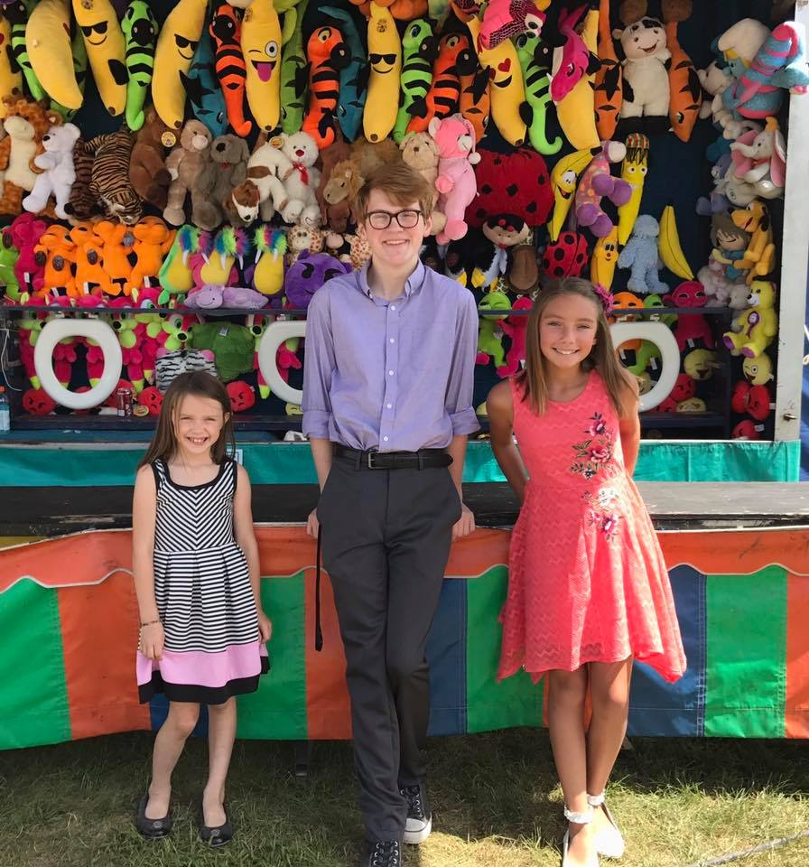
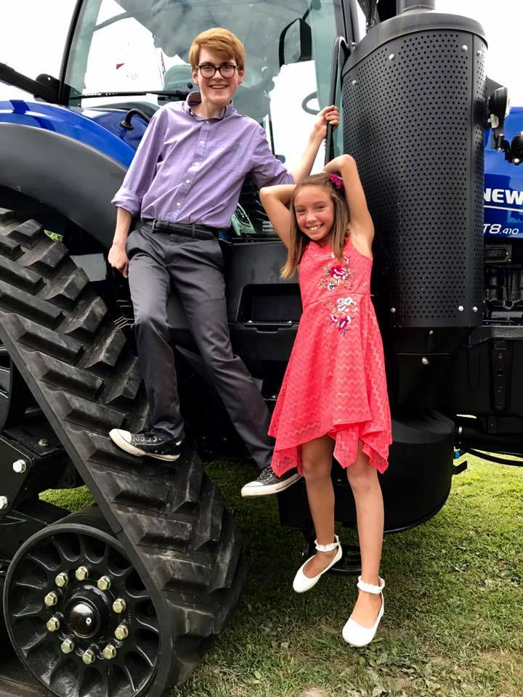
WEBSTER COUNTY FAIR BILL RILEY STATE FAIR TALENT SEARCH
Participating in the Webster County Fair Bill Riley State Fair Talent Search Show on July 12 was Hannah Lukehart. Hannah sang “How Far I’ll Go” in the Sprout Division. She is 11 years old and the daughter of Christina Sells and Johnny Lukehart. Providing piano accompaniment was area pianist, Michelle Havlik-Jergens. Hannah is a voice student of MaryAnn McSweeny-Buhr.

